aspera

Aspera Voice
Meal Logging
  - Product experience and technical architecture
Technical white paper September 2026
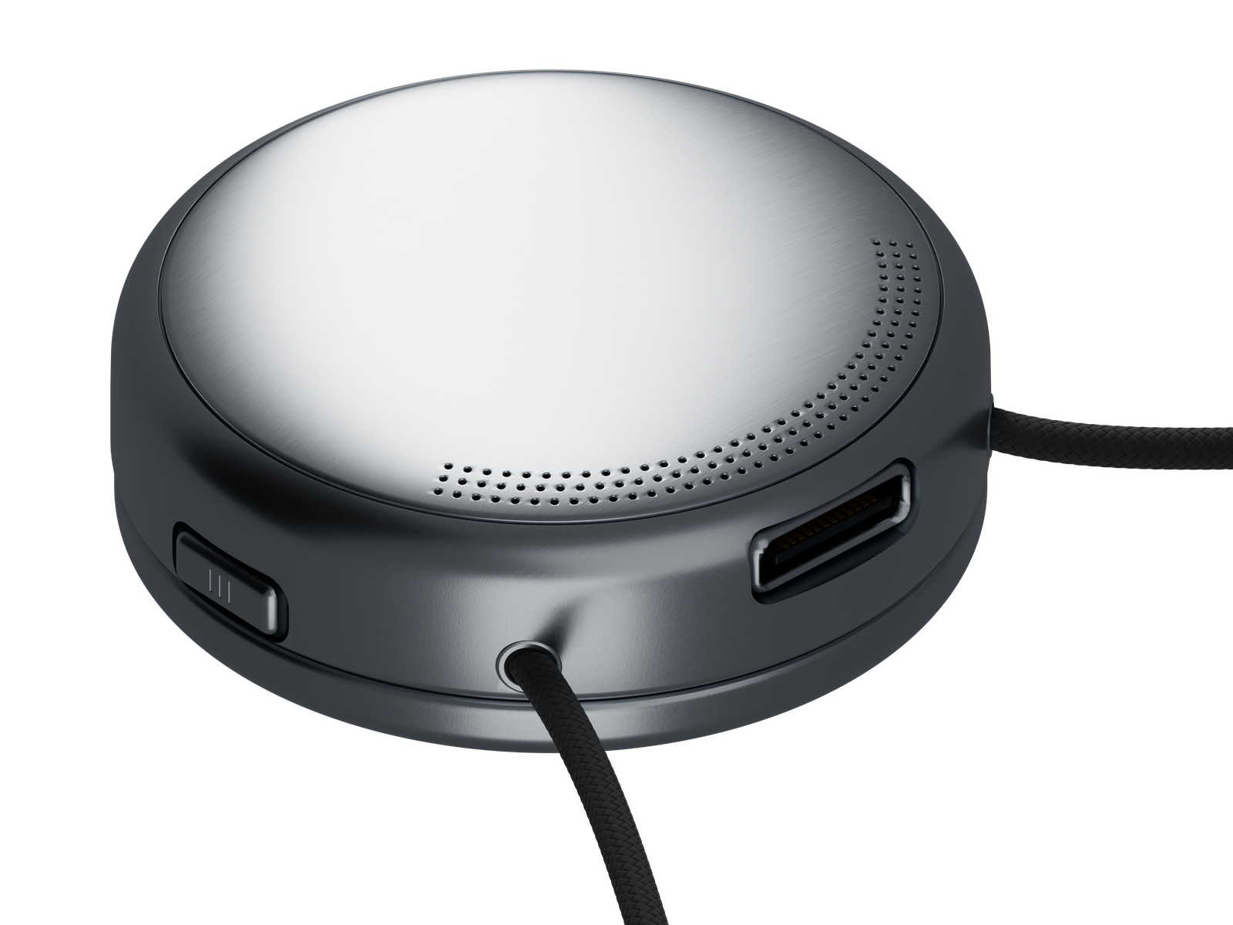
Aspera concept render
Aspera is a nutrition pendant being developed by Aura Technologies LLC. Its intended workflow captures a spoken meal, then prepares a suggested food entry for review in MetricSync.
This paper describes a proposed implementation, from audio capture to a confirmed daily log. A saved recording preserves the moment; user review determines what enters the food record. Contact: contact@aura-technologies.co
01

Product overview
Aspera is intended to give meal logging a physical starting point: hold a pendant, describe a meal, then release. The planned MetricSync companion app would prepare a suggested entry for the user to inspect and confirm.

The problem the product addresses
Recording meals asks people to interrupt ordinary activity and reconstruct details. A description can be incomplete even when the user remembers the dish. Portions, preparation and extras influence the estimate. Aspera’s product hypothesis is that an accessible recording control can preserve useful context, while a later review step makes the resulting entry easier to correct.
A study of 72 adults in a behavioral weight loss program found dietary logging adherence averaged 49.34% of days in months 4–11. A valid day required at least five foods logged. Only 21% met at least 50% adherence in every observed month. These findings concern that study population; they establish neither consumer retention nor a benefit from Aspera. [1]

What the system is designed to produce
The output is a user-confirmed meal record containing foods, amounts, estimated nutrients and enough source context to revisit the estimate. The record contributes to a daily summary. The system should also retain unresolved suggestions separately, so an incomplete interpretation never appears indistinguishable from a checked entry.

Development scope
The founder reports a 3D-printed enclosure, battery and Seeed Studio hardware with partially working audio capture and Bluetooth transfer to an app. No reliability results or complete food-processing workflow are verified. The architecture below is proposed; automated suggestions, durable synchronization and production controls require implementation and testing.
The intended use is personal nutrition awareness. The product does not measure consumed nutrients directly, and this design makes no claim of medical benefit or clinical accuracy. Any future disease-related functions would require a separate assessment of evidence and regulatory obligations. The FDA’s general wellness guidance describes a relevant policy context, not a product-specific determination for Aspera. [6]
02

The meal logging experience
A recording and a meal entry represent different states. The first preserves the user’s description. The second records an interpretation that the user has accepted.

Capture at the user’s request
Pressing and holding starts a bounded recording. Releasing ends it. The device should make both events clear, using feedback that can be recognized in normal surroundings. Accidental presses, maximum recording length and cancellation need explicit behavior. An interface should never imply that audio was saved when storage or power prevented completion.

Describe enough to support review
The user can speak naturally: “I had two chapatis, a bowl of dal, and a glass of milk.” The description identifies likely foods but leaves several quantities open. A household measure should remain a household measure until an appropriate conversion or user correction supplies a defensible amount.
Spoken detail | What it establishes | What may need review
Two chapatis | Food and count | Size, recipe and added fat
A bowl of dal | Dish and container | Lentil preparation and bowl amount
A glass of milk | Beverage | Volume and milk type

Table 1 A natural description can establish some fields while leaving others open

Review when the phone is available
MetricSync should show the original wording alongside the suggestion. The user checks the matched food, serving amount and any extras, then corrects or rejects the proposal. When ambiguity materially affects the estimate, the app asks a focused question, such as the amount of milk, rather than silently adding a precise number.
Confirmation commits an entry to the log. The user should still be able to edit it later. A later edit creates a new revision and recalculates the relevant summary. Suggested entries remain visible as pending work, with a clear distinction between waiting for processing and waiting for the user.
03

The reference architecture
The pendant handles capture. The phone manages transfer and review. A processing layer interprets the description and looks up candidate nutrition records.
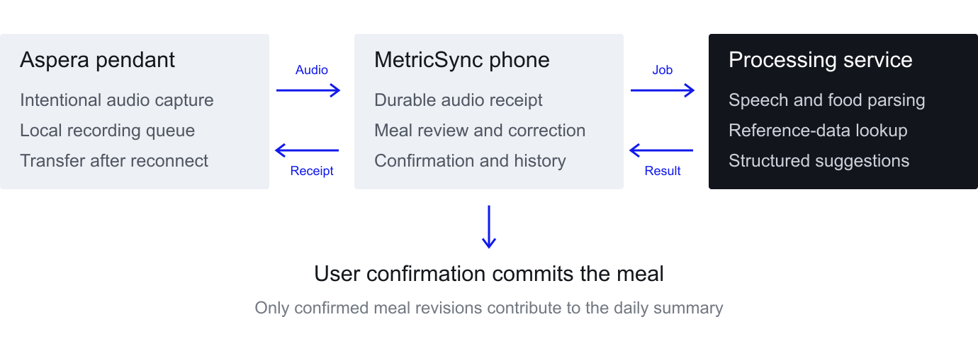
Figure 1 Proposed responsibilities and data movement

Pendant responsibilities
A physical control, microphone, local storage and a Bluetooth interface form the functional capture path. Firmware creates a recording identifier, closes the audio file safely, and queues the record for transfer. Device selection must follow measured acoustic performance, storage needs, power use and physical constraints, rather than an assumed specification.

Phone responsibilities
The phone pairs with the device, receives recordings into durable storage and tracks their state. It schedules processing, presents pending entries and owns the confirmation interface. An app restart or lost connection should not remove the user’s last visible state or cause the same recording to become multiple meals.

Processing responsibilities
The processing layer transcribes audio, extracts food mentions, retrieves reference candidates and computes a structured suggestion. The reference design allows a server to perform these steps. A future local implementation can preserve the same contract if its quality and resource use are acceptable. Offline recording therefore does not imply offline transcription or nutrition analysis.
Each stage returns an explicit outcome: completed, needs input, retryable failure or permanent failure. Shared identifiers connect the audio record, processing attempts, meal proposal and confirmed entry. This separation allows retries without changing what the user has already confirmed.
04

Recording and synchronization
Reliable capture requires a durable handoff. A Bluetooth connection by itself does not prove that an entire recording has reached persistent storage.

A bounded local recording
Firmware should debounce the control, record only during an intentional capture session and finalize the file on release. Each record needs a unique identifier, format version, audio length, byte length, checksum and device timestamp with a time-quality indicator. A temporary file can protect against partial writes: only a successfully closed record enters the ready-to-transfer queue.
Capacity and battery behavior must be observable. When storage is full, the device should report failure rather than overwrite an untransferred recording. A low-power shutdown should preserve completed files and mark an interrupted recording as incomplete. The user should be able to remove an unwanted capture.

Transfer with a durable acknowledgement
Bluetooth LE supplies connected communication through its protocol stack, with application data commonly organized through GATT services and characteristics. [4] A proposed Aspera transfer service would expose record metadata, control messages and bounded chunks of audio. Chunk sequence information and a resume position allow the phone to continue after a disconnect.
The phone verifies the complete byte count and checksum, commits the record to local storage, then sends a record-level acknowledgement. The pendant may reclaim the file only under the retention policy after that acknowledgement. Link-layer acknowledgement is insufficient for this purpose because it confirms packet reception, not durable application storage.

Duplicate prevention and recovery
The device and phone should use the same recording identifier for retries. Receiving a record twice updates one transfer record rather than creating two meals. Processing requests use that identifier plus a versioned job key. A timeout changes the job state to retryable without discarding the source audio.
The app should distinguish “saved on pendant,” “received on phone” and “ready for review.” Reconnection behavior must account for mobile operating-system limits on background execution. The promise to transfer later needs device testing across app restarts, permissions changes, power loss and connection interruptions.
05

Speech and food interpretation
Speech recognition proposes what the user said. Food matching proposes what those words refer to. Keeping those steps separate makes uncertainty easier to inspect and correct.

Transcription
The transcription stage should preserve the original audio link, language information, model version and text output. Noise, overlapping speech, unfamiliar food names and code switching can change the words recognized. Low-confidence or incomplete audio should produce a reviewable transcript or a clear failure, not an invented meal.
A language model can help structure the transcript, but it should not provide nutrient values from memory. The service should validate its output against a schema and require each extracted food to retain the phrase that supports it. Optional fields stay empty when the description does not establish them.

Food extraction and candidate retrieval
A proposed food object contains the stated food name, quantity, unit, preparation, brand if spoken, and relevant modifiers. Negation matters: “coffee without sugar” must not add sugar. Shared dishes and partial servings need their own amount interpretation. The system should retain a dish as a dish until it has a sound basis for splitting ingredients.
Candidate retrieval would search a nutrition reference. USDA FoodData Central offers food search and detail APIs with data types that need different interpretation. [2] This is a possible source, not a demonstrated Aspera integration. Regional recipe and brand coverage needs evaluation; additional licensed sources may be needed.

Candidate ranking and clarification
The service ranks candidates using the spoken name, preparation, brand, unit compatibility and any confirmed personal defaults. A raw food reference is not interchangeable with a cooked one. When several candidates remain plausible, the app should show a concise choice or ask for the one detail most likely to resolve the ambiguity.
Repeated corrections may support personal defaults, but those defaults must be visible and editable. They should not silently override an explicit statement. The service should store the selected source identifier, source version or retrieval date, and the reasons a proposal still needs review. A model confidence score becomes meaningful only after calibration against labeled examples.
06

Portions and nutrition estimates
Food identity determines the reference. Portion size determines how much of that reference contributes to the meal. Both must remain visible to the user.

A consistent calculation basis
For a reference expressed per 100 g, the amount of a nutrient in a serving equals the serving mass in grams divided by 100, multiplied by the nutrient value per 100 g. USDA’s Foundation Foods documentation describes nutrient and portion data and the relationship between reference values and a portion. [3] Other source formats must be normalized before calculation.
Serving nutrient = serving mass ÷ 100 × nutrient per 100 g
Invented example, using 4/4/9 kcal/g for protein/carbohydrate/fat. Real database energy may use food-specific factors. These values are not measured food data or accuracy results. [3]
Nutrient | Illustrative value per 100 g | For a 150 g serving
Energy | 106 kcal | 159 kcal
Protein | 6 g | 9 g
Carbohydrate | 18 g | 27 g
Fat | 2 g | 3 g

Table 2 Each example reference value is multiplied by 1.5

Household portions and mixed dishes
“A bowl” has no universal mass. The app needs a food-specific portion record, a user-entered weight, or an explicit estimate that the user can change. It should store the conversion basis. Raw-to-cooked conversions require a suitable yield assumption and should never happen invisibly.
A recipe can use a complete dish reference or a sum of ingredients allocated to the consumed share. Those paths must not double count the same food. Added oil, sauces, toppings and leftovers need explicit treatment. The output should carry missing values as unknown rather than zero.

Precision and limits
Food references, recipes and descriptions introduce uncertainty. Confirmation checks intent, not chemical composition. Round display values while retaining calculation precision. Estimated ranges need a defined, evaluated method; store source versions so past estimates remain explainable.
07

Confirmation and the meal record
A confirmed entry should be traceable to its interpretation and source data. The proposed model separates a capture, a suggestion and a user-approved revision.
Record | Minimum purpose and fields
Capture | Recording ID, device ID, timestamps, audio reference, checksum, transfer state
Suggestion | Capture ID, transcript, extracted foods, source candidates, unresolved fields, processing version
Meal revision | Meal ID, revision ID, selected foods, amounts, nutrients, source references, confirmation time
Daily summary | Local date, included meal revisions, nutrient totals and completeness indicators

Table 3 Proposed logical data model rather than a committed API schema

The confirmation boundary
The confirmation action should be an atomic write: it creates or updates the approved meal revision and marks the suggestion as handled. Repeating the same request should return the same result. If the connection fails, the app should clearly show whether the confirmation is saved locally and waiting to synchronize.
User edits create revisions rather than silently replacing the source interpretation. Removing a meal excludes it from summaries. The system should keep enough audit information to explain changes without retaining raw audio indefinitely. Multiple devices editing the same entry require an explicit conflict rule, such as a version check followed by a user-visible resolution.

Daily totals and missing information
A daily nutrient total adds the values from the currently confirmed meal revisions assigned to that local date. The app should distinguish the time of eating from the time of recording and preserve the user’s time zone. Late entries and travel can otherwise place a meal on the wrong day.
Pending captures and unconfirmed proposals should never inflate a total. A day without an entry is missing information, not evidence that the user ate nothing. When a nutrient is missing for one food, the app can report the known subtotal with a completeness indicator. It should avoid presenting that subtotal as a complete daily intake.
08

Privacy and user control
Intentional capture is the first privacy control. Retention, access and deletion determine what happens after the recording ends.

Data minimization
The reference design records only an explicit session and provides a clear indication of capture. A meal recording may still include another person’s speech or private background information. The system should keep raw audio only for a defined purpose and duration, separate from the longer-lived confirmed food record.
The user should be able to inspect and delete recordings, correct transcripts and export or remove meal records. Deletion must propagate through the device queue, phone storage and server objects where applicable. Backup retention and delayed deletion behavior need a clear policy. Retaining data for model improvement would require its own disclosed choice.

Protection across the data path
The proposed design uses authenticated device ownership, appropriately secured Bluetooth pairing, encrypted application transport and encryption for stored sensitive data. Exact controls depend on the chosen hardware and mobile platforms. Pairing should resist unauthorized attachment to an existing owner’s device. A lost pendant and an account sign-out need deliberate behavior.
Service credentials belong outside shipped application code. A backend can broker reference-data requests, apply rate limits and cache permitted results. USDA explicitly assigns API-key holders responsibility for keeping their keys private. [2] Operational logs should use job identifiers and avoid storing complete audio, transcripts or meal content by default.

Processing providers and operational access
Before selecting a speech or language service, the implementation should establish where data goes, how long the provider retains it, whether it enters training, and how deletion requests are handled. Access to recordings should be restricted to the work that requires them. Any support access needs authorization and an audit trail.
The review experience should make uncertainty ordinary: “portion to check” is a useful state, not an error to hide. Personal nutrition awareness also benefits from neutral language and user-adjustable display preferences. Accuracy, retention and privacy claims should correspond to implemented controls that the team can demonstrate.
09

Failures and recovery
Failure handling is part of the product experience. The user needs to know what was saved, what remains pending and what action can recover the meal.
Failure | Expected system behavior | User-facing outcome
Phone unavailable | Keep completed audio on the pendant until durable transfer | Saved and waiting for connection
Interrupted transfer | Resume or retry with the same recording ID | Transfer pending without a duplicate
Unclear or empty audio | Keep the capture and return a processing failure | Retry or enter the meal manually
Ambiguous food or portion | Return candidate choices and unresolved fields | A focused review question
Nutrition source unavailable | Retry lookup without fabricating nutrient values | Entry pending or saved without a complete estimate
Confirmation timeout | Resolve the idempotent request before creating another revision | Clear saved or pending status
Storage exhausted | Protect untransferred records and reject new capture clearly | A visible need to sync or remove recordings

Table 4 Proposed failure contract across capture, processing and review

Recovery without hidden loss
A failure should not advance the entry to confirmed. The phone can show a pending queue with a reason and a recovery action. The queue should make old unresolved recordings easy to find, while allowing the user to discard them deliberately. Retry policies need limits so a failing service does not create unbounded battery, bandwidth or processing costs.
The system should distinguish a recoverable interruption from a corrupt or incomplete recording. A checksum detects transfer corruption, but does not prove audio intelligibility. Quality checks should therefore consider file integrity and whether the captured speech is usable.
10

Validation and development priorities
Aspera must demonstrate that the full experience improves usable logging. Counting audio captures alone would overstate success if users rarely complete the review.

Technical validation
Device testing should exercise intentional presses, accidental activation, storage limits, low power and repeated reconnects. Measure the rate of complete captures and successful durable transfers, with a separate count of lost or duplicated records. Evaluate acoustic intelligibility in the situations the product expects users to encounter, including movement and background conversation.
For interpretation, assemble a consented evaluation set spanning target accents, languages, food types and portion expressions. Label food identity, quantity, preparation, exclusions and unresolved details. Report food matching errors and portion errors separately. Compare nutrient estimates with weighed or otherwise documented reference meals, and state the reference method’s own limitations.

A comparative user pilot
A useful pilot compares Aspera with phone-only voice capture while keeping food processing and review comparable. MyFitnessPal already documents a phone voice workflow with editable results, so voice availability alone is not the test. [5] A counterbalanced crossover can help distinguish the value of wearing a capture control from a novelty effect.
Predefine the primary outcome and a meaningful improvement threshold before collecting results. Useful measures include confirmed meals per day, retention over the observation period, total capture-plus-review time, correction burden and wear frequency. Track how often a recording reaches confirmation. Collect qualitative reasons for abandoned reviews and days when the device was not worn.

Decisions before production
The next milestone is a reliable capture-to-confirmation prototype, extending the founder-reported partial hardware. The second is evidence from a representative pilot and error evaluation. Production planning should follow a costed device design, battery and charging tests, durability work and an assessment of applicable product requirements. Hardware reliability and support effort belong in the commercial model.
A device purchase with an optional MetricSync subscription is one commercial hypothesis. Pricing requires willingness-to-pay evidence and measured unit costs. Device margin must include fulfillment, returns and warranty. Service economics must account for processing, storage and support. A successful pilot should inform whether the wearable’s value justifies those costs.
11

References and terminology
[1] Crane N, Hagerman C, Horgan O, Butryn M. Patterns and Predictors of Engagement With Digital Self-Monitoring During the Maintenance Phase of a Behavioral Weight Loss Program. JMIR mHealth and uHealth. 2023;11:e45057.
Read source
[2] US Department of Agriculture, Agricultural Research Service. FoodData Central API Guide.
Read source
[3] US Department of Agriculture, Agricultural Research Service. FoodData Central Foundation Foods Documentation.
Read source
[4] Bluetooth SIG. The Bluetooth Low Energy primer.
Read source
[5] MyFitnessPal. Voice Logging. Help article updated August 5, 2025.
Read source
[6] US Food and Drug Administration. General Wellness Policy for Low Risk Devices. Guidance issued January 2026.
Read source
Sources rechecked September 5, 2026. References support the stated research or technical background. They do not imply affiliation, integration agreements or validation of Aspera.

Key terms
Capture: a bounded audio recording. Suggestion: an unconfirmed interpretation of a capture. Confirmed meal: the food record the user approves. Durable acknowledgement: confirmation that the receiving application has safely stored a complete record. Idempotency: repeated requests with the same key produce one logical result. GATT: the Generic Attribute Profile used to organize Bluetooth application data.

Product basis
Aspera is a project of Aura Technologies LLC. Prototype status is founder-reported as of September 5, 2026. Images show intended design renders. The proposed engineering requirements are not a record of production behavior or independently tested performance.

